Dual mode of deep oscillation magnetron sputtering
V.O. Oskirko^{a,b}, A.N. Zakharovª, A.P. Pavlov^{a,b}, А.А. Solovyevª, A.S. Grenadyorovª,
V.A. Semenovª
ªInstitute of High Current Electronics, Siberian Branch, Russian Academy of Sciences, 2/3, Akademichesky Ave., Tomsk, 634055, Russia
^{b}Applied Electronics LLC, 15-80, Akademichesky Ave., Tomsk, 634055, Russia

Abstract. Deep oscillation magnetron sputtering (DOMS) is a promising variation of the high-power impulse magnetron sputtering technique which prevents the arc formation during reactive magnetron sputtering. The paper presents the experimental results of discharge in the dual DOMS mode. High-power bipolar micropulse packets are used for the dual DOMS discharge power source, which form a 1–3-ms-duration macropulses. The current-voltage characteristic of discharge is measured in the dual DOMS mode, and the pulse waveform of the ion current on the substrate is analyzed. It is shown that during a macropulse, the substrate is exposed to a continuous ion bombardment. Plasma parameters, such as electron temperature, electron concentration, and ion current density are measured and compared using a triple Langmuir probe in three sputtering modes (DC, dual mid-frequency and dual DOMS). Moreover, the ion-to-atom arrival ratio on the substrate is evaluated for the indicated modes of sputtering aluminum targets. The dual DOMS performance is demonstrated by Al₂O₃ and TiO₂ dielectric coating deposition in the reactive sputtering mode. The possibility is shown for arc-free coating deposition with the sputtering mode stabilization via control for parameters of electrical discharges. Aluminum oxides obtained at a low (300°C) substrate temperature, include θ-phase, possess rather high hardness (15 GPa) and large transmission in the visible range. Titanium oxide coatings are characterized by 11 GPa hardness, 3.1–3.5 eV band gap width and consist mostly of the rutile phase.
Keywords: deep oscillation magnetron sputtering, dual magnetron sputtering, plasma parameters, reactive sputtering, Al₂O₃ coating, TiO₂ coating

1. Introduction
High power impulse magnetron sputtering (HiPIMS) [1, 2] and its modulated pulse power magnetron sputtering (MPPMS) variation [3, 4] are up-to-date techniques of highly-ionized physical vapor deposition. Both techniques provide high plasma concentration and high ionization degree of the sputtered material allowing depositing coatings having such qualities that are difficult to gain when using the traditional direct current magnetron sputtering (DCMS) or mid-frequency magnetron sputtering (MFMS). A new form of MPPMS is deep oscillation magnetron sputtering (DOMS) characterized by 1000–3000 µs long pulses of discharge current representing 3–20 µs micropulse packets. An interval between micropulses prevents the formation of electric arcs even in reactive magnetron sputtering modes [5]. The micropulse current amplitude can achieve several hundreds of amperes, the discharge power density being several times higher than in continuous modes of magnetron sputtering.
A great number of publications have appeared in the last few years documenting the advantages of the DOMS technique over others. Using Cr and Ti metallic films in [6–8], it is demonstrated that micropulse packets used for the discharge power source reduce the problem of lowering the coating deposition rate typical of HiPIMS. Control for micropulse frequency and duration in DOMS increases the deposition rate by several tens of percent in comparison with HiPIMS, while maintaining a high level of the ion bombardment of the substrate. DOMS is considered to be a promising method of production of diamond-like carbon coatings, since the content of sp³ carbon in coatings turns to be higher than in DCMS [9–12]. The increased fraction of ionized sputtered species with increasing peak discharge power allows to suppress the columnar structure and improve the hardness of Cr [13], CrN [14] and Cr₂O₃ [15] coatings. Without extra heating and bias potential onto the substrate, DOMS generates TiO₂ films high in the rutile phase [16], and α-phase in Ta coatings [17]. DOMS is a tool for eliminating the shadow effect which leads to non-uniform treatment of complex substrates [18, 19]. DOMS is also used in the formation of coatings with complex compositions, such as TiSiN [20], TiAlSiN [21] and CrN/TiN [22–24], in which control for the pulsed-discharge power governs the coating nanostructure.
In this paper, we offer to modify the DOMS technique. Unlike the DOMS systems used earlier, we suggest the dual magnetron sputtering system (MSS) instead of a single MSS schematically illustrated in Fig. 1. The dual MS mode is widely used in industrial reactive sputtering-based coating systems. In the dual MS, magnetrons act alternately as cathode and anode, depending on the power source (PS) polarity.
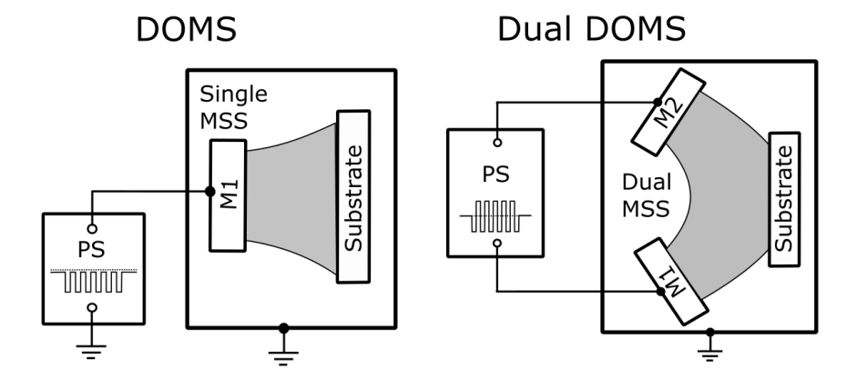
Fig. 1. Schematic of DOMS and dual DOMS modes with voltage impulse curves at the power source output.
This paper aims to consolidate the advantages of the DOMS and dual MS modes in one device resulting in several important priorities. First, the dual MSS solves the problem of disappearing anode [25], which arises in reactive sputtering of dielectric coatings. Second, besides the discharge power increase, which enables the ion current growth on a substrate, the latter will be provided by a closed magnetic field configuration of the dual magnetron [26]. Third, the dual MSS implies the use of a bipolar power source which will allow us to avoid long intervals between micropulses typical of DOMS. A periodic change in voltage polarity without long intervals will enhance the discharge power density and quick compensation of spurious charges accumulating on the target surface and causing arc formation.
This paper presents the first results of a study of a new system, which will be referred to as dual DOMS hereinafter. In the first part of the work, a description of a pulsed bipolar power source is presented. The second part discusses the electric discharge and plasma parameters of aluminum metal sputtering. Considered are the pulse waveform of the discharge current and voltage, the variation range of the pulsed-discharge power, plasma concentration and ion current density on the substrate. The third part shows the experimental results of aluminum metal sputtering and Al₂O₃ and TiO₂ coating deposition in the reactive dual DOMS mode.

2. Experimental setup
The schematic diagram of the dual DOMS setup is presented in Fig. 2. This experimental setup is designed for coating deposition in the dual DOMS mode. As can be seen from this figure, the setup includes a vacuum chamber, pumping and gas regulating systems, dual magnetron sputtering system (dual MSS), dual DOMS power source (PS), ion source (IS) with the power source (IS PS), rotating substrate holder, heater power source (HPS), discharge voltage current detectors, triple Langmuir probe (TLP), measurement circuit for TLP signals, and digital oscilloscope.
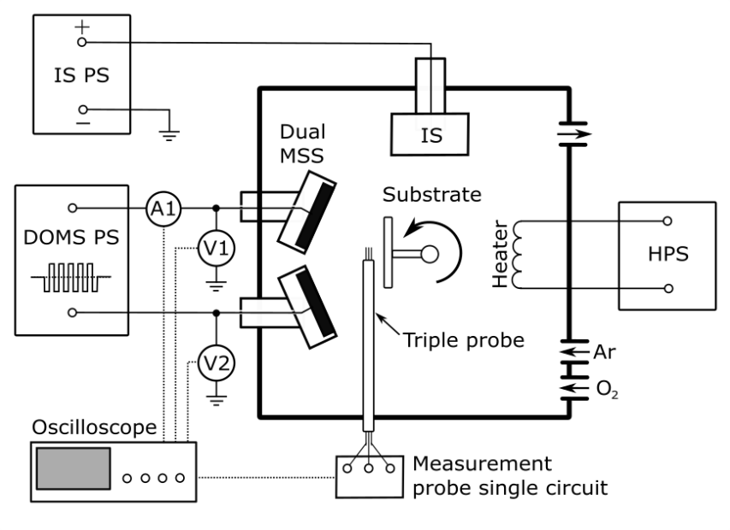
Fig. 2. Schematic of the experimental setup for dual DOMS-based discharge.

The dual MSS with 5 mm thick Al targets having a diameter of 76 mm is mounted to a side of the vacuum chamber. The maximum working power of the sputtering system is 3 kW in the continuous mode. The magnetic system of magnetrons is slightly unbalanced, with the coefficient of geometrical unbalance of K_{G} = 1.2, which can be obtained from [27]:

K_{G} = Z₀/2R,

where Z₀ is the distance on the system axis from the target surface to the point, where magnetic field lines reverse direction, R is the average radius of the erosion zone.

The magnetic field on the cathode surface is 730 G in the racetrack region. The dual MSS has a closed magnetic field configuration, i.e. magnetic field lines are linked between the magnetrons resulting in low losses of secondary electrons on the chamber walls. The angle between the target surfaces is 158°.

An APEL-DU-DOMS-1500 (Applied Electronics LLC, Russia) power source is used for power the discharge. Figure 3 illustrates the pulse waveforms of discharge voltage and current in the dual DOMS mode, and Table 1 summarizes main output parameters of the power source and the range of their regulation.

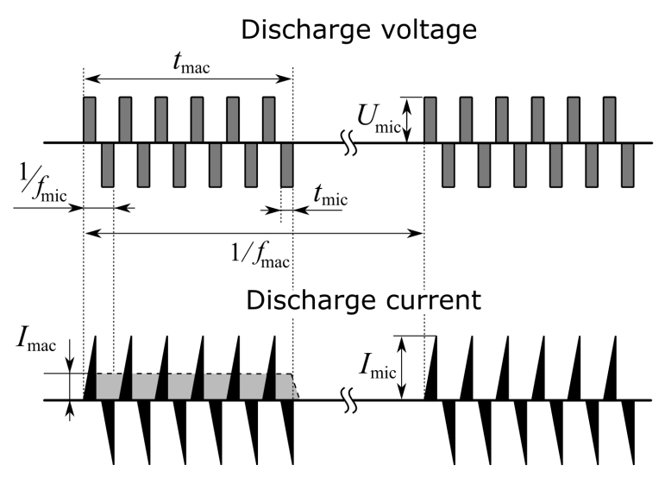

Fig. 3. Pulse waveforms of discharge voltage and current in the dual DOMS mode.

Table 1. Main parameters of the dual DOMS power source
Parameters | Designation | Range
Discharge voltage (amplitude of micropulse) | U_{d} | 100–1500 V
Average discharge current | I_{d} | 0–12 А
Average macropulse current | I_{mac} | up to 100 A  up to 200 A
Maximum micropulse current | I_{mic}
Average discharge power | P_{d} | 0–10 kW
Average macropulse power | P_{mac} = I_{mac}· U_{d} | up to 150 kW
Maximum micropulse power | P_{mic} = I_{mic}· U_{d} | up to 300 kW
Macropulse frequency | f_{mac} | 0–1000 Hz
Macropulse duration | t_{mac} | 100–3000 µs
Macropulse duty cycle | k_{mac} | 0.1–100 %
Micropulse frequency | f_{mic} | 10–50 kHz
Micropulse duration | t_{mic} | 3–50 µs

The dual DOMS PS is equipped with a capacitor capable of storing energy up to 5 kJ, which allows it to provide macropulse duration up to 3000 µs at high values of the output current. The PS has an arc suppression system which limits the maximum current to 200 А. The dual DOMS PS operates in the mode of the output voltage stabilization, average discharge current stabilization or average discharge power stabilization. Besides the dual DOMS mode, the power source operates both in the dual MFMS and DCMS modes.

The dual DOMS PS operates in symmetric and asymmetric modes. In the symmetric mode, positive and negative pulses have similar amplitudes. In the asymmetric mode, the individual amplitude adjustment of bipolar pulses is possible in one of the three stabilization modes. This allows varying the deposition rate for each target separately and making control for its surface state in the reactive sputtering mode. In this work we use the symmetric mode of PS operation.

Prior to the coating deposition, the substrates are cleaned by the ion source with closed electron drift. The ion source is supplied by a high-voltage power source IS PS (3.5 kV, 600 mA, 2 kW) (Fig. 2). Substrates are heated from a resistance heater. The substrate temperature is measured by a thermocouple. The residual and operating pressure in the vacuum chamber is 6·10⁻³ and 0.3 Pa, respectively. Plasma parameters are measured by a triple Langmuir probe placed near substrates, at a 12 cm distance from the target surface. The TLP determines the instantaneous values of electron temperature (T_{e}) and electron density (N_{e}) [28]. All potentials of the TLP system locate in the vicinity of the floating potential of plasma, such that high currents cannot damage the probe and relatively slightly excite plasma around it. Owing to the absence of monotonely changing voltage on individual probes, the plasma parameters can be measured in a very short period of time. The TLP is low sensitive to plasma oscillations as all three of its electrodes experience a simultaneous disturbance.

The thickness of the obtained coatings was measured with a Linnik interference microscope MII-4 (LOMO, Russia). A NanoTest 600 hardness tester (Micro Materials Ltd., Great Britain) was used to measure the coating hardness by Oliver and Pharr method. Phase composition and structure of the specimens were investigated on the XRD-6000 X-ray Diffractometer (Shimadzu, Japan). Measurements were conducted using Cu Kα radiation. The International Centre for Diffraction Data (ICDD), Denver, USA, maintaining the Powder Diffraction File (PDF-4+) was used for qualitative analysis of the phase composition and the PowderCell 2.4 Rietveld program. The transmission and reflection spectra were measured using a SF-256 UV–VIS spectrophotometer in the wavelength range 200–1000 nm in order to obtain the optical properties of oxide coatings.

3. Results and discussion

3.1 Pulse waveform of discharge voltage and current in the dual DOMS mode

Let us discuss the results obtained for the pulse waveform of discharge voltage and current in the dual DOMS mode measured in sputtering Al targets in pure argon. Figure 4а presents macropulse waveforms of discharge current in the output circuit of the dual DOMS PS and those of discharge voltage of М₁ and М₂ targets measured relative to earth. During a 1000-µs macropulse, the dual MSS targets are exposed to negative voltage pulses of a 35 kHz frequency and 12 µs duration. The discharge current periodically changes the direction, thereby providing alternate sputtering of both targets.
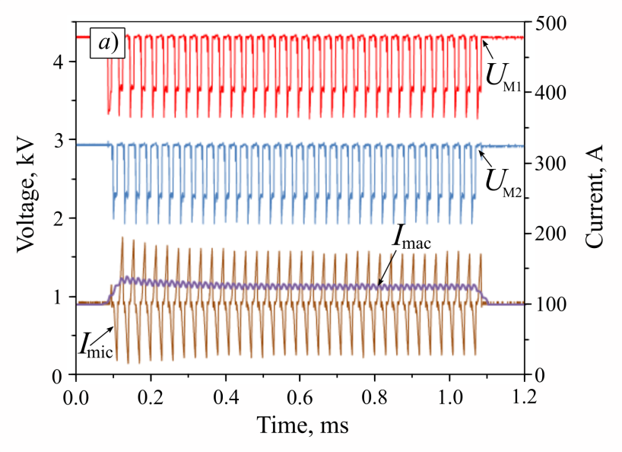

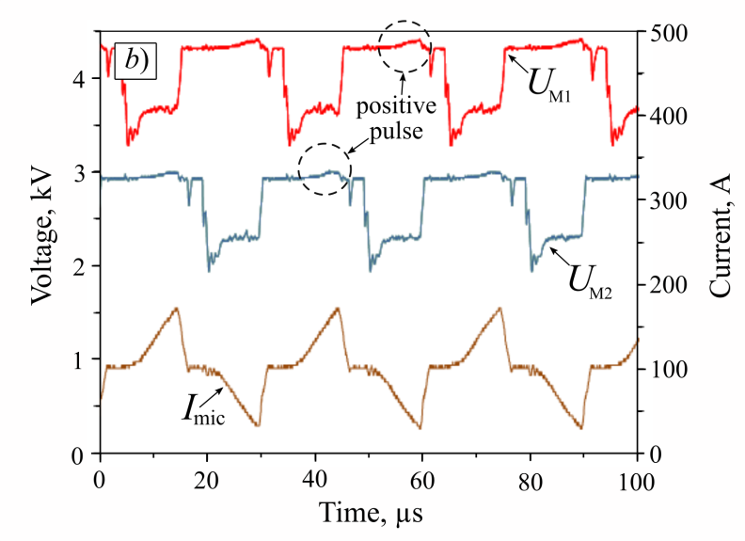

Fig. 4. Waveforms of macropulses (a) and micropulses (b) of discharge voltage and current in the dual DOMS mode.

The amplitude of micropulse voltages U_{M1} and U_{M2} is not changed during a macropulse, whereas the amplitude of micropulse current I_{mic} lowers from 80–90 to 70 А during the first 300 µs. The latter can be explained by gas heating and the reduction in gas pressure nearby the cathode [29]. Higher values of discharge current at the initial stage of the macropulse development provide an increase in the plasma concentration and the ion current density on the substrate. The average value of the macropulse current I_{mac} can be found in Fig. 4а.

According to Fig. 4b, the micropulse waveform of discharge current is triangular. This is because the discharge has no time to stabilize during the micropulse, and the linear current increase occurs. The interval between micropulses is necessary for the current decrease and energy recovery which is stored in the PS output circuit. The length of the interval is about 5 µs.

The voltage micropulse waveform is more complex. At the initial stage of the negative voltage micropulse, the discharge-gap resistance is high, and the dual DOMS PS full voltage of the storage capacity is then applied to the targets. When the discharge current rapidly increases, the voltage micropulse amplitude reduces from 900 to 650 V and keeps constant until the micropulse stops. The voltage drop is associated with inductance in the power circuit. At a rapid increase in the discharge current, the voltage of the PS storage capacity redistributes between the inductance and the discharge gap.
During the interval between the negative voltage pulses, the targets work as an anode. At this time, the anode fall ranges between 20 and 30 V, the potential amplitude being increased with the growth in the discharge current (see Fig. 4b, dotted circles). The positive potential of the target functioning as an anode depends on its area and plasma concentration in the discharge gap. In the dual DOMS mode, when the targets are electrically isolated from the vacuum chamber, the anode area is small and equals that of the target. At the same time, the magnetic field on the anode surface further impedes its ability to extract electrons from plasma. With increasing discharge current, the potential redistribution occurs in the discharge gap so that to provide in it a balance of currents.

3.2 Current-voltage characteristic of discharge in the dual DOMS mode
The current and power control in the dual DOMS mode is performed by varying the amplitude of the micropulse voltage U_{d}. Consider Fig. 5а, which plots the dependence between the average macropulse current I_{mac} and voltage U_{d} at the micropulse frequency of 20, 35 and 50 kHz (closed symbols). The voltage micropulse duration t_{mic} decreases with the micropulse frequency and is 20, 12 and 5 µs, respectively. In this experiment, the discharge voltage is increased up to its threshold value during the activation of the current protective system. The average discharge power is 1 kW and kept constant throughout the experiment.
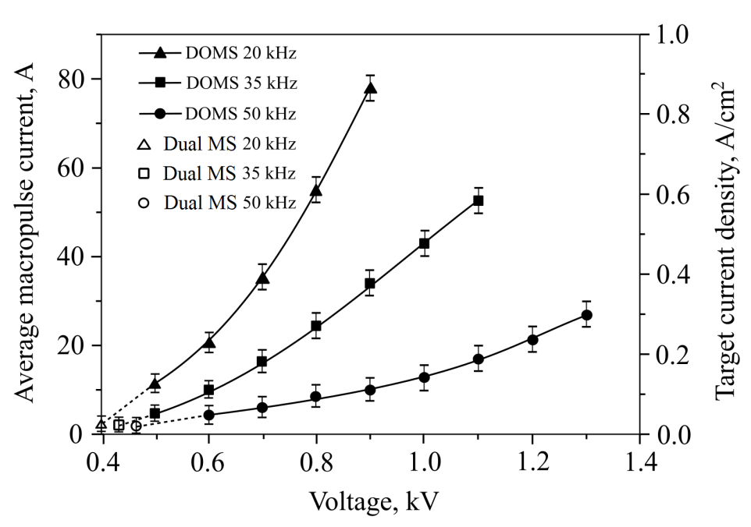
Fig. 5. Dependence of average values of macropulse current and current density on the target on micropulse voltage.
The maximum value of I_{mac} = 80 А is achieved at a 20 kHz frequency and U_{d} = 900 V discharge voltage. At a frequency of 35 and 50 kHz, the maximum voltage reaches 1100 and 1300 V, respectively, while the average macropulse current decreases down to 50 and 27 А, respectively. As shown in Fig. 5, at the frequency fall, the curves move upward and becomes steeper. Thus, at the same voltage, with decreasing micropulse frequency of discharge current, the micropulse amplitude becomes substantially larger. The average current density on the target surface of the dual MSS is J_{20 kHz} = 0.9 А/сm², J_{35 kHz} = 0.6 А/сm² and J_{50 kHz} = 0.3 А/сm², and the average macropulse power is P_{20 kHz} = 780 W/сm², P_{35 kHz} = 640 W/сm² and P_{50 kHz} = 390 W/сm².
In Fig. 5 one can also see the average values of discharge current and current density on the target in the dual MS mode at 1 kW average discharge power and similar micropulse frequencies (open symbols). In the dual MS mode, the power density on the target is 11 W/сm² and the current density ranges between 23–27 mА/сm². Thus, using the dual DOMS metal mode, we increase the average current density and the discharge power by more than an order of magnitude as compared to conventional dual magnetron sputtering.
In order to keep the average discharge power constant (1 kW) in the dual DOMS mode, the increased pulsed-discharge power is compensated by the decrease in the macropulse frequency f_{mac}. Fig. 6 describes the dependences of the macropulse duty factor k_{mac}, which is equal to the ratio between the macropulse duration and frequency and the macropulse frequency f_{mac} on the discharge voltage U_{d}.
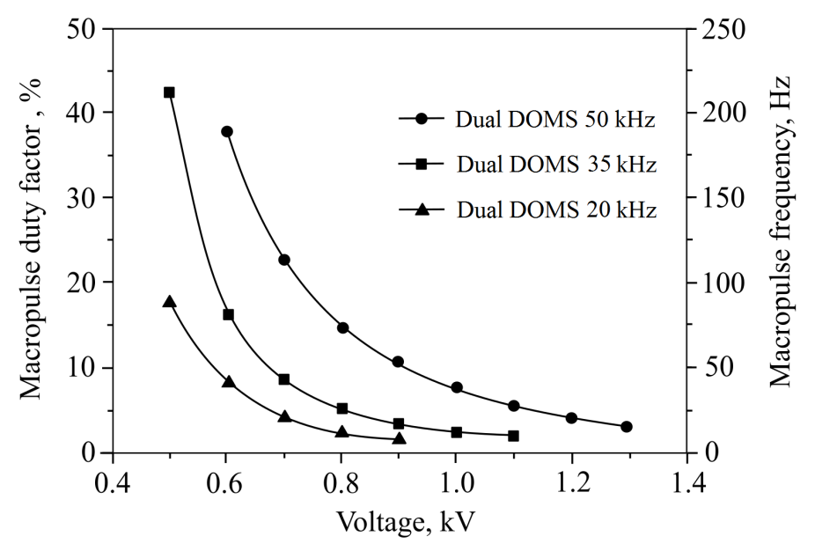
Fig. 6. Dependence of macropulse duty factor and macropulse frequency on discharge voltage at 20, 35 and 50 kHz micropulse frequency. Average discharge power: 1 kW. Macropulse duration: 2000 µs. Argon pressure: 0.25 Pa.
According to Fig. 6, the macropulse frequency ranges from 7 to 210 Hz, the duty factor lying between 1.4 and 43 %. The arc formation is avoided throughout the whole range.
3.3 Comparison of plasma parameters in DCMS, dual MS and dual DOMS modes
Several modes of magnetron sputtering were used to measure plasma parameters by the triple Langmuir probe. In the DCMS mode, the targets were supplied by the constant voltage, the vacuum chamber walls worked as an anode. In the dual MS mode, the targets were supplied by continuous bipolar pulses with a frequency of 35 kHz. In the dual DOMS 1–5 modes the targets were supplied by macropulses with the frequency ranging from 10 to 250 Hz, at t_{mac} = 2 ms and f_{mic} = 35 kHz. In all the indicated modes, the average discharge power was constant (1 kW), i.e. 500 W for each magnetron. For visual representation of the measurement results of plasma parameters one can address to Table 2. After the target pre-training, the arc-free coating deposition was carried out.
Table 2. Pulsing and plasma parameters for various modes of magnetron sputtering.
Modes | f_{mac,} kHz | k_{mac}, % | U_{d}, V | I_{d}, А | I_{mic}, А | I_{mac}, A | P_{mic}, kW | P_{d}, kW | P_{mac}, kW | J_{mac}, mА/cm² | J_{avg}, mА/cm² | T_{e}, eV | N_{e}, 10¹¹cm⁻³
DCMS | - | 100 | 359 | 2.8 | - | - | - | 1.00 | - | - | 0.71 | 3.8 | 0.2
Dual MS | - | 100 | 465 | 2.1 | 6.5 | - | 3.0 | 0.99 | - | - | 1.34 | 2.7 | 0.6
Dual DOMS 1 | 250 | 50 | 500 | 1.96 | 13 | 4.7 | 6.5 | 0.98 | 2.1 | 2.8 | 1.4 | 5.4 | 0.9
Dual DOMS 2 | 80 | 16 | 600 | 1.63 | 32 | 10.3 | 19 | 1.02 | 6.2 | 5.9 | 0.95 | 3.1 | 2.0
Dual DOMS 3 | 50 | 10 | 700 | 1.44 | 50 | 16.6 | 35 | 1.01 | 11.6 | 8.5 | 0.73 | 3.2 | 3.2
Dual DOMS 4 | 15 | 3 | 900 | 1.10 | 100 | 34 | 90 | 0.99 | 30.6 | 14.0 | 0.46 | 3.2 | 5.0
Dual DOMS 5 | 10 | 2 | 1100 | 0.90 | 160 | 52.5 | 176 | 0.99 | 57.8 | 18.5 | 0.31 | 3.1 | 7.0
Notation: J_{mac} – ion current density on the probe during a macropulse; J_{avg} – average ion current density over a period; T_{e} – electron temperature; N_{e} – electron concentration.
In the dual DOMS mode, the decrease in the macropulse frequency leads to the increase in the discharge voltage U_{d}, pulse currents I_{mac} and I_{mic}, and discharge powers P_{mac} and P_{mic}. In the dual DOMS mode 5, the discharge voltage is 3 times higher than in the DCMS mode and 2.5 higher than in dual mid-frequency sputtering. In the case of the dual DOMS mode 5, the pulse current and discharge power values increase by tens of times. At a 160 А pulse current, the pulsed-discharge power reaches its maximum of 176 kW, which is 50 times higher than the average discharge power. In this mode, the ion current density on the probe and electron concentration during a macropulse are 18 mА/сm² and 7·10¹¹ cm⁻³, respectively, i.e. ten times higher than the respective average values in the DCMS and dual MS modes. As the average discharge power P_{d} is constant throughout the experiment, the growth in the discharge voltage U_{d} is accompanied by lowering the average discharge current I_{d}, which enables a decrease in the average ion current J_{avg} passing to the probe during one period.
When changing the DCMS mode by the dual MS mode, we observe the electron temperature fall from 3.8 to 2.7 eV. The pulsed-discharge power rise in the dual DOMS mode is also accompanied by the electron temperature fall from 5.4 to 3.1 eV, which can be explained by growing plasma concentration.
3.4 Waveform of ion current to the substrate in the dual DOMS mode
A 80×80 mm flat-surface substrate was used to explore the pulse waveform of the ion current passing to that substrate in the dual DOMS mode. The flat-surface substrate was positioned at a 120 mm distance to the target surface of the dual MSS. Negative potential of 60 V was supplied to the substrate.
Waveforms presented in Fig. 7 describe macro- and micropulses of the discharge current and the ion current on the substrate. From this figure it can be seen that during a macropulse, the continuous ion current flows onto the substrate. The micropulse discharge current amplitude is 20 А in a steady-state mode. During a macropulse, the average ion current on the substrate is 0.6 А, which matches an 8.2 mА/сm² ion current density on the substrate.
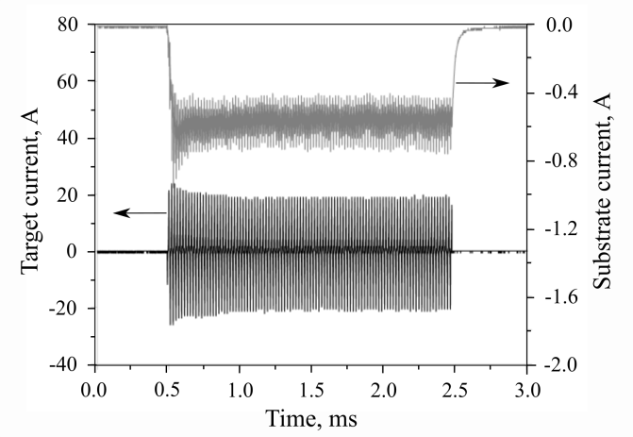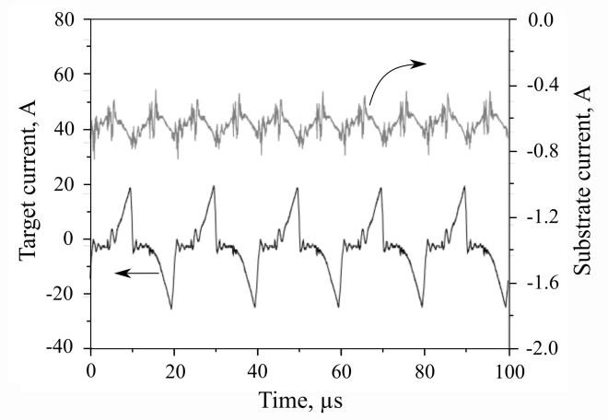
b)
a)
Fig. 7. Waveforms of macro- (а) and micropulses (b) of discharge current and ion current on the substrate at t_{mac} = 2 ms and f_{mic} = 50 kHz.
According to Fig. 7b, the oscillation frequency of the ion current on the substrate is 100 kHz, which corresponds to the doubled micropulse frequency of discharge current. During a micropulse, the ion current on the substrate grows, while during the interval between micropulses, it lowers. The deviation between instantaneous and mean values of the ion current is ± 0.1 А, i.e. ~20 % of the mean value. Waveforms given in [9, 15] show the stronger oscillations of the ion current on the substrate in the common DOMS mode with a single magnetron. Due to long intervals of several tens of micrometers, the ion current decrease is 50 % and over. As we have already noted, it is no need to create long intervals in the dual DOMS mode, and so the ion current has no time to substantially modify. Thus, during a macropulse, the continuous, high-density ion current is maintained on the substrate. We then can assume that the micropulse frequency exceeding 50 kHz reduces oscillations of the ion current on the substrate.
3.5 Al coating deposition in DC, dual MS and dual DOMS modes
Along with the ion current passing to the substrate, the ion-to-atom arrival ratio F_{i}/F_{a} on the substrate is an important parameter of ion-plasma deposition. If we know the ion current density on a substrate and the deposition rate, this ratio can be found from
$F_{i}= \frac{J_{avg}}{e}$, $F_{a}=\frac{A_{d}ρ}{M_{a}}$,
where J_{avg} is the ion current density on the substrate during a period, mA/cm²; e is the unit charge (e = 1.6·10⁻¹⁹ C ); A_{d} is the coating deposition rate; ρ is the average coating density (2.7 g/cm³ for Al); М_{а} is the mass of Al atom (0.44·10⁻²² g). The sticking coefficient of the arriving aluminum atoms to the substrate is assumed to be close to unity.
In order to find the F_{i}/F_{a} ratio, we performed Al deposition using three sputtering modes from Table 2, namely DCMS, dual MS and dual DOMS 5. The coatings were deposited onto glass substrates positioned at the points of measuring the ion current density. Table 3 summarizes the results of measuring the deposition rate and the current density of ions and atoms.
Table 3. Ion current density, deposition rate, and F_{i}/F_{a} ratio for three modes of Al coating deposition
Modes | J_{avg}, mA/cm² | a_{d}, nm/s | F_{i}, cm⁻²s⁻¹ | F_{a}, cm⁻²s⁻¹ | F_{i} /F_{a}
DCMS | 0.7 | 2.78 | 4.37·10¹⁵ | 1.68·10¹⁶ | 0.26
Dual MS | 1.3 | 2.12 | 8.13·10¹⁵ | 1.28·10¹⁶ | 0.64
Dual DOMS | 0.5 | 0.75 | 2.88·10¹⁵ | 0.45·10¹⁶ | 0.64

The highest density of the ion current on the substrate is observed in the dual MS mode. The deposition rate and, consequently, the flow of neutral atoms on the substrate F_{a} decrease during the transfer from DCMS to pulsed sputtering. In the dual MS mode, the deposition rate lowers by 25 %, while in the dual DOMS mode it lowers by 4 times as compared to the DCMS mode. Such a significant reduction in the deposition rate in the dual DOMS mode indirectly indicates that a significant fraction of Al atoms are ionized during the macro pulse and some of them return to the target under the influence of an electric field. In the DCMS mode, the high deposition rate at a low average density of the ion current provides the lowest F_{i}/F_{a} ratio among the three sputtering modes. In the both pulsed sputtering modes, F_{i}/F_{a} ratio equals 0.64, which is 2.5 times higher than in the DCMS mode.
3.6 Al₂O₃ coating deposition in dual MS and dual DOMS modes
Al₂O₃ coatings were produced in the reactive dual MS and dual DOMS modes at an average discharge power of 1 kW. As is known [30], the substrate temperature should be high (700 °C) in order to grow crystalline alumina coatings. One of the methods to lower the temperature of crystallite growth in coating is enhancement of the adatom mobility through low-energy ion bombardment [31]. As far as the dual DOMS mode provides high-density (18 mА/сm²) ion current on a substrate during a macropulse, the coating deposition is carried out at a moderate substrate temperature of 300°С under thermocouple control.
The reactive sputtering process is stabilized via control for the electric discharge parameters. Ar flow rate was 180 sccm in all experiments. The pressure in the chamber was 0.3 Pa. In the dual MS mode, the pulse frequency was 50 kHz at a 50% duty cycle. The dual DOMS mode includes 5 µs duration and 50 kHz frequency for a micropulse and 2 ms duration and 200 kHz frequency for a macropulse.
It is important to note that in the non-reactive dual DOMS mode, the maximum pulsed-discharge current achieves 200 А at a 20 kHz micropulse frequency, which corresponds to a 4.4 A/cm² peak current density on the target. In the reactive sputtering mode, the maximum pulsed-discharge current which provides arc-free deposition of alumina coatings is considerably lower (20 А). In increasing pulsed-discharge current above this value, multiple arcs appear on the targets. The increased micropulse frequency prevents the arc formation. A stable process of arc-free coating deposition can be provided by the power source via the increase in the maximum micropulse frequency up to 50 kHz.
Figure 8 plots the dependencies between the magnetron discharge voltage and oxygen flow rate (hysteresis curves) in the dual MS and dual DOMS modes. At first, the O₂ flow rate increases from 0 to 35 sccm and then reduces again to 0 sccm. According to Fig. 8, a small hysteresis is observed in the dual DOMS mode, although in the literature data, the hysteresis effect is often absent in either the reactive HiPIMS or MPPMS modes. For instance, in [32], the authors describe hysteresis-free zirconium oxide coating deposition in the reactive HPPMS mode. The work [33] reports on niobium sputtering in O₂/Ar gas mixture using the hysteresis-free HiPIMS mode between the metallic and the poisoned target state. It was determined in [33], that the voltage at the cathode of the magnetron is the main parameter affecting the behavior of the reactive discharge.
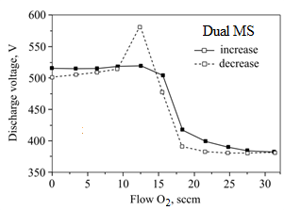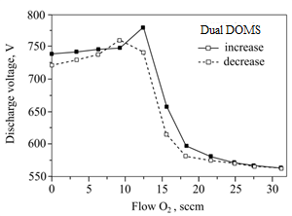
b)
a)
Fig. 8. Target voltage as a function of O₂ flow rate (hysteresis curves) in dual MS (a) and dual DOMS (b) modes.
As experiments show, the dual DOMS mode is also capable of stabilizing the process of reactive sputtering Al₂O₃ coatings via regulation of discharge voltage. This requires the power source functioning in the power stabilizing mode. The oxygen flow rate was increased or decreased in manual way so that to increase or decrease the magnetron discharge voltage to the point of return to a preset value. This method of the reactive process stabilization gives an opportunity of deposing oxide coatings in transition mode from metallic to oxide. In contrast to [16], where over 40 µs micropulse off time is used to achieve arc-free coating deposition at a comparative value of the peak target current density, the dual DOMS mode allows us to reduce this time down to 5 µs.
Table 4 gives the alumina coating deposition parameters for the dual MS and dual DOMS modes. In the dual DOMS mode, the maximum rate of the alumina coating deposition is 57 nm/min, which is 72 % of the deposition rate in the metal mode at the same average discharge power. In the dual MS mode, the maximum rate of the alumina coating deposition is 58 % of the dual MS metal mode. In general, in the dual MS mode, the deposition rate is 35 % higher than in the dual DOMS mode.
Table 4. Alumina coating deposition parameters for the dual MS and dual DOMS mode
Modes |  | U_{d}, V | O₂ flow rate, sccm | Deposition rate, nm/min | Fraction of the metallic rate, %
Dual DOMS | 1 | 740 | 0 | 79 | 100
 | 2 | 730 | 14.0-15.7 | 57 | 72
 | 3 | 645 | 16.3-16.7 | 28 | 35
 | 4 | 565 | 35 | 3 | 4
 | 5 | 515 | 0 | 134 | 100
Dual MS | 6 | 500 | 15.0-16.8 | 78 | 58
 | 7 | 450 | 17.2-21.3 | 36 | 27
 | 8 | 383 | 35 | 7 | 5

The transmission of alumina coatings ~2 µm thick obtained in the dual DOMS mode №2 and the dual MS mode №6 and deposited onto glass substrates 1 mm thick is given in Fig. 9.
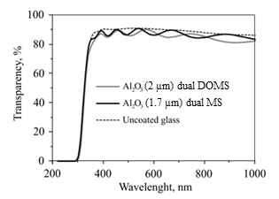
Fig. 9. Transmission of Al₂O₃ coatings deposited onto glass substrates.
Al₂O₃ coating deposition without the substrate heating and at O₂ flow rate lower than 12 sccm, generates amorphous coatings with ~9 GPa hardness. The substrate heating up to 300°С and the O₂ flow rate over 15 sccm result in a 15.2 GPa coating hardness both in dual MS and dual DOMS modes. The structure of the coatings became closer to polycrystalline. A small peak of alumina θ-phase is observed on the X-ray diffraction (XRD) pattern at 2θ = 43.76° (Fig. 10b).
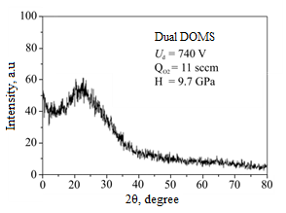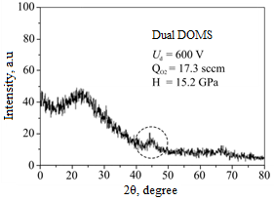
b)
a)
Fig. 10. Grazing-incidence XRD patterns of dual DOMS mode-deposited Al₂O₃ coatings at 300°C substrate temperature and different oxygen rates: а – 11 sccm, b – 17.3 sccm.
Figure 11 shows the cross-sectional SEM image of Al₂O₃ coating 2 µm thick deposited onto a silicon substrate. The coating structure is dense glassy-like.

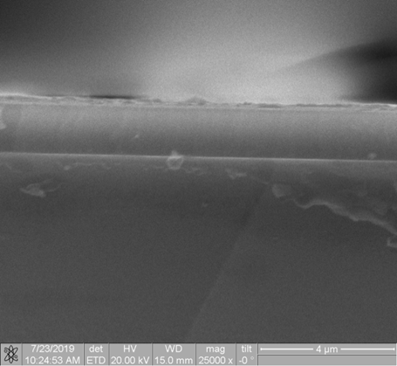
Fig. 11. Cross-sectional SEM image of dual DOMS-deposited Al₂O₃ coating. Average discharge power: 1 kW. Oxygen flow rate: 17.3 sccm.
3.7 TiO₂ coating deposition in reactive dual DOMS mode
The dual DOMS mode was also used produce TiO₂ coating onto glass substrates. TiO₂ coatings were deposited at a rate of 7–9 nm/min in a poisoning mode. The discharge power of 1 kW and oxygen flow rate of 18 sccm were kept constant throughout the process. The dual DOMS operating parameters included 5 µs duration and 50 kHz frequency for a micropulse and 2 ms duration and 200 kHz frequency for a macropulse, 16 А maximum pulse current, 30 А maximum pulsed-discharge current, and 100 Hz macropulse frequency. The substrates were not heated during the deposition process. The thickness of the obtained TiO₂ coatings was 750 nm. In both modes, the XRD patterns showed the presence of the dominant rutile phase (over 85%) (see Table 5).
The grazing-incidence XRD pattern typical to dual DOMS-deposited TiO₂ coating is given in Fig. 12. One can see the anatase (101) and rutile (110) diffraction peaks on this XRD pattern. The maximum discharge current increased from 16 to 30 А, leads to a small growth in the grain size of the rutile phase (from 16 to 19 nm) and a small reduction in residual elastic strain (from 3.54 to 2.96). The deposition rate lowers from 9 to 7 nm/min.
Lin, et al. [16] showed that in the dual DOMS mode, TiO₂ films deposited at a low target peak current (50 A) contained mainly the anatase phase. A complete rutile phase was obtained by DOMS at a 200 A target peak current only.
Table 5. Results of the XRD analysis of TiO₂ coatings deposited in the dual DOMS mode.
TiO₂ coating | Detected phases | Phase content, wt.% | Lattice parameters, Ǻ | Grain size, nm | Strain  Δd/d·10⁻³
Dual DOMS I_{mic} = 16 A | Rutile | 88 | a = 4.5802  c = 2.9807 | 16 | 3.54
 | Anatase | 12 | a = 3.8072  c = 9.5682 | 13 | 4.39
Dual DOMS I_{mic} = 30 A | Rutile | 89 | a = 4.5889  c = 2.9400 | 19 | 2.96
 | Anatase | 11 | a = 3.7689  c = 9.6783 | – | –

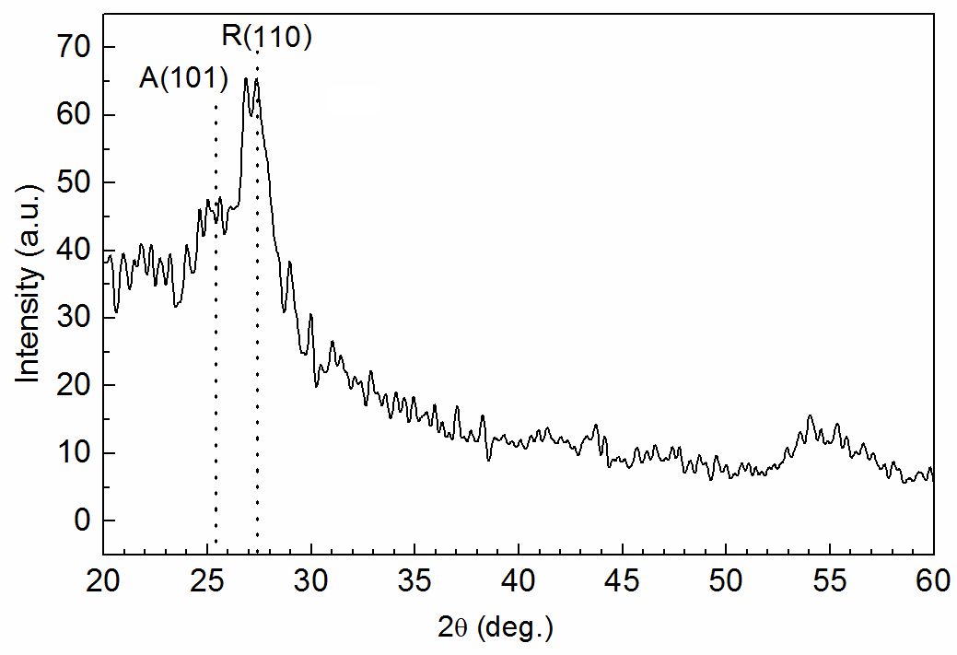
Fig. 12. Typical grazing-incidence XRD pattern of dual DOMS-deposited TiO₂ coating. A – anatase phase, R – rutile phase.
The hardness of the obtained TiO₂ coatings is 11 GPa, which is good agreement with the literature data on TiO₂ coatings consisting mostly the rutile phase [16].
The ultraviolet (UV)–visible (Vis) absorption spectra of two TiO₂ coatings obtained at two different pulse currents are shown in Fig. 13а. The high transmission is observed for both coatings in the visible region. In the UV region of 320–400 nm, the transmission decreases rapidly and approaches to zero at shorter wavelengths. The strong UV-light absorption is a characteristic phenomenon for TiO₂ coatings [34]. At 360–400 nm wavelengths, the absorption edge additionally indicates to a high content of the rutile phase in the coating, as in the anatase-dominant TiO₂ coatings, the absorption edge is on the longer wavelengths. The rutile phase shows a higher refractive index and stability than the anatase phase and usually used as dielectric and anti-reflective coatings [35].
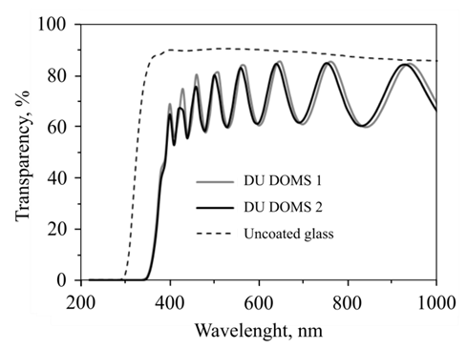
a)
b)
Fig. 13. UV–Vis transmission spectra of TiO₂ coatings deposited onto glass substrates in dual DOMS mode at different pulse currents: 1 – 30 A, 2 – 16 A; a – uncoated glass substrate; b – variation of (α·hν)^{1/2}, hν – photon energy.
If we know the coating thickness and the absorption coefficient derived from the transmission and reflectance spectra, we can calculate the width of the energy band gap E_{g}. The coting reflectance ranges between 10 and 35%. And the absorption coefficient α is calculated as [36]:
${T≈(1-R^{2})∙e}^{-αt}$,
where α is the absorption coefficient; t is the coating thickness, cm; R is the reflectance at a respective wavelength; T is the transmission at a respective wavelength.
The Tauc plot is used to determine the band gap width. This method consists of obtaining the dependence (α·hν)^{1/n} vs hν and drawing a tangent to it. The resulting intersection between the tangent and hν axis yields the band gap width, while the curve slope helps to detect the Tauc parameter B^{1/n}. The Tauc equation is as follows [36]:
$${(α∙hν)}^{1/n}=B^{1/n}∙(hν-E_{g})$$
where B is the constant (Tauc parameter), E_{g} is the band gap width, hν is the photon energy, α is the absorption coefficient, n is the ability that characterizes electronic transitions (direct and indirect) in a substance during absorption.
According to [37], TiO₂ coatings are described by allowed indirect transitions, such that n = 2. Figure 12b presents (α·hν)^{1/2}–hν dependence for TiO₂ coating produced in the dual DOMS mode. In both investigated modes, the width of the band gap is similar and equals ~3.1 eV.

4. Conclusions
In conclusion, this study has evidently demonstrated a number of specific features of the DOMS mode used in the dual configuration of the magnetron sputtering system.
First, the DOMS technique was used in the dual magnetron sputtering system. 1–3-ms-duration macropulses of discharge current represented bipolar micropulse packets with 20–50 kHz frequency and 5–20 µs duration. In the dual DOMS metal mode used for Al target sputtering, the discharge power was 50 times higher than its average value during a macropulse. The limit value of the discharge power during a macropulse was determined by 200 А maximum allowable pulse current the power source was able to provide.
Second, during a macropulse, the substrate was exposed to a continuous ion bombardment, and the current density reached 20 mА/сm². During a macropulse, the ion current on the substrate grew, whereas during the interval its decrease did not exceed 20% of the mean value. The alternate operation of two magnetrons reduced the interval between micropulses, and consequently reduced the oscillation amplitude of the ion current on the substrate relative to the common DOMS mode.
Third, Al coating deposition in the dual DOMS mode showed that the ion-to-atom arrival ratio is similar to that in the dual mid-frequency mode. The decrease in the deposition rate at the increased pulsed-discharge power was accompanied by the proportional decrease in the average ion current density on a substrate during the period, although the pulsed ion current density on a substrate was significantly higher.
Fourth, in the reactive dual DOMS mode, the pulsed-discharge power range was considerably lower than in the dual DOMS metal mode. At Al coating deposition, the maximum micropulse amplitude of discharge current was 200 А and restricted by the power source, while in depositing Al₂O₃ and TiO₂ coatings it was 20 and 30 А, respectively. These were limit values of the pulse current, at which the process of arc-free coating deposition was stabilized. At higher values of the micropulse amplitude, the appeared arc formation prevented the discharge power control.
This paper has clearly shown that stabilization of Al₂O₃ deposition in the dual DOMS mode could be provided via the parameter control of electric discharge. The maximum rate of Al₂O₃ deposition was 72 % of that in the dual DOMS metal mode. At 300°С substrate temperature, the obtained Al₂O₃ coatings had a polycrystalline structure and 15 GPa hardness. The coatings were highly transparent in the visible range.
The important observation in this study was that the titanium oxide coatings produced in the dual DOMS mode without the additional substrate heating and negative substrate bias voltage were high in the rutile phase (over 80 %) and characterized by high transparency and hardness. The dual DOMS mode created highly ionized plasma that changed the gas reactivity and the growing coating surface by ion bombardment, facilitating the formation of TiO₂ crystal phase.
Acknowledgements
The authors gratefully acknowledge the Russian Foundation for Basic Research and the Tomsk Region Administration (grant no. 15-08-03332) for financial support.
References
[1] V. Kouznetsov, K. Macák, J. Schneider, U. Helmersson, I. Petrov, A novel pulsed magnetron sputter technique utilizing very high target power densities, Surf. Coat. Technol. 122 (1999). 209–293.
[2] U. Helmersson, M. Lattemann, J. Bohlmark, A.P. Ehiasarian, J.T. Gudmundsson, Ionized physical vapor deposition (IPVD): A review of technology and applications, Thin Solid Films 513 (2006) 1–24.
[3] J. Lin, J.J. Moore, W.D. Sproul, B. Mishra, J.A. Rees, Z. Wu, R. Chistyakov, B. Abraham, Ion energy and mass distributions of the plasma during modulated pulse power magnetron sputtering, Surf. Coat. Technol., 203 (2009) 3676–3685.
[4] J. Lin, W.D. Sproul, J.J. Moore, Z. Wu, S. Lee, R. Chistyakov, B. Abraham, Recent advances in modulated pulsed power modulated sputtering for surface engineering, JOM 63(6) (2011) 48–58.
[5] J. Lin, High rate reactive sputtering of Al₂O₃ coatings by HiPIMS, Surf. Coat. Technol. 357 (2019) 402–411.
[6] O. Antonin, V. Tiron, C. Costin, G. Popa, T.M. Minea, On the HiPIMS benefits of multi-pulse operating mode, J. Phys. D Appl. Phys. 48(1) (2015) 015202.
[7] P.M. Barker, E. Lewin, J. Patscheider, Modified high power impulse magnetron sputtering process for increased deposition rate of titanium, J. Vac. Sci. Technol. A 31 (2013) 060604.
[8] P.M. Barker, S. Konstantinidis, E. Lewin, N. Britun, J. Patscheider, An investigation of c-HiPIMS discharges during titanium deposition, Surf. Coat. Technol. 258 (2014) 631–638.
[9] J. Lin, W.D. Sproul, R. Wei, R. Chistyakov, Diamond like carbon films deposited by HiPIMS using oscillatory voltage pulses, Surf. Coat. Technol. 285 (2014) 1212–1222.
[10] F. Ferreira, A. Aijaz, T. Kubart, A. Cavaleiro, J. Oliveira, Hard and dense diamond like carbon coatings deposited by deep oscillations magnetron sputtering, Surf. Coat. Technol. 336 (2018) 92–98.
[11] F. Ferreira, R. Serra, A. Cavaleiro, J. Oliveira, Diamond-like carbon coatings deposited by deep oscillation magnetron sputtering in Ar-Ne discharges, Diam. Relat. Mater. 98 (2019) 107521.
[12] J. Lin, X. Zhang, P. Lee, R. Wei, Thick diamond like carbon coatings deposited by deep oscillation magnetron sputtering, Surf. Coat. Technol. 315 (2017) 294–302.
[13] F. Ferreira, R. Serra, J.C. Oliveira, A. Cavaleiro, Effect of peak target power on the properties of Cr thin films sputtered by HiPIMS in deep oscillation magnetron sputtering (DOMS) mode, Surf. Coat. Technol. 258 (2014) 249–256.
[14] F. Ferreira, J.C. Oliveira, A. Cavaleiro, CrN thin films deposited by HiPIMS in DOMS mode, Surf. Coat. Technol. 291 (2016) 365–375.
[15] J. Lin, W.D. Sproul, Structure and properties of Cr₂O₃ coatings deposited using DCMS, PDCMS, and DOMS, Surf. Coat. Technol. 276 (2015) 70–76.
[16] J. Lin, B. Wang, W.D. Sproul, Y. Ou, I. Dahan, Anatase and rutile TiO₂ films deposited by arc-free deep oscillation magnetron sputtering, J. Phys. D Appl. Phys. 46(8) (2013) 084008.
[17] F. Ferreira, C. Sousa, A. Cavaleiro, A. Anders, J. Oliveira, Phase tailoring of tantalum thin films deposited in deep oscillation magnetron sputtering mode, Surf. Coat. Technol. 314 (2017) 97–104.
[18] J.C. Oliveira, F. Ferreira, A. Anders, A. Cavaleiro, Reduced atomic shadowing in HiPIMS: Role of the thermalized metal ions, Appl. Surf. Sci. 433 (2018) 934–944.
[19] F. Ferreira, R. Serra, A. Cavaleiro, J.C. Oliveira, Additional control of bombardment by deep oscillation magnetron sputtering: Effect on the microstructure and topography of Cr thin films, Thin Solid Films 619 (2016) 250–260.
[20] J.C. Oliveira, F. Fernandes, F. Ferreira, A. Cavaleiro, Tailoring the nanostructure of Ti–Si–N thin films by HiPIMS in deep oscillation magnetron sputtering (DOMS) mode, Surf. Coat. Technol. 264 (2015) 140–149.
[21] Y.X. Ou, H. Chen, Z.Y. Li, J. Lin, W. Pan, M.K. Lei, Microstructure and tribological behavior of TiAlSiN coatings deposited by deep oscillation magnetron sputtering, J. Am. Cceram. Soc. 101(11) (2018) 5166–5176.
[22] Y.X. Ou, J. Lin, S. Tong, W.D. Sproul, M.K. Lei, Structure, adhesion and corrosion behavior of CrN/TiN superlattice coatings deposited by the combined deep oscillation magnetron sputtering and pulsed dc magnetron sputtering, Surf. Coat. Technol. 293 (2016) 21–27.
[23] Y.X. Ou, J. Lin, S. Tong, H.L. Che, W.D. Sproul, M.K. Lei, Wear and corrosion resistance of CrN/TiN superlattice coatings deposited by a combined deep oscillation magnetron sputtering and pulsed dc magnetron sputtering, Appl. Surf. Sci. 351 (2015) 332–343.
[24] Y.X. Ou, H.Q. Wang, B. Liao, M.K. Lei, X.P. Ouyang, Tribological behaviors in air and seawater of CrN/TiN superlattice coatings irradiated by high-intensity pulsed ion beam, Ceram. Int. 45(18) (2019) 24405–24412.
[25] W.D. Sproul, D.J. Christie, D.C. Carter, Control of reactive sputtering processes, Thin Solid Films 491 (2005) 1–17.
[26] M. Yusupov, E. Bultinck, D. Depla, A. Bogaerts, Behavior of electrons in a dual-magnetron sputter deposition system: a Monte Carlo model, New J. Phys. 13 (2011) 033018.
[27] I.V. Svadkovski, D.A. Golosov, S.M. Zavatskiy, Characterisation parameters for unbalanced magnetron sputtering systems, Vacuum 68(4) (2002) 283–290.
[28] S.L. Chen, T. Sekiguchi, Instantaneous direct display system of plasma parameters by means of triple probe, J. Appl. Phys. 36 (1965) 2363–2375.
[29] A. Anders, Discharge physics of high power impulse magnetron sputtering, Surf. Coat. Technol. 205 (2011) 1–9.
[30] B. Hirschauer, S. Soderholm, G. Chiaia, U.O. Karlsson, Highly oriented α-alumina films grown by pulsed laser deposition, Thin Solid Films 305 (1997) 243–247.
[31] Q.Z. Li, Y.H. Yu, C.S. Bhatia, L. Marks, S.C. Lee, Y.W Chung, Low-temperature magnetron sputter-deposition, hardness, and electrical resistivity of amorphous and crystalline alumina thin films, J. Vac. Sci. Technol. A 18(5) (2000) 2333.
[32] K. Sarakinos, J. Alami, C. Klever, M. Wuttig, Process stabilization and enhancement of deposition rate during reactive high power pulsed magnetron sputtering of zirconium oxide, Surf. Coat.Technol. 202 (2008) 5033–5035.
[33] M. Hála, J. Čapek, O. Zabeida, J.E. Klemberg-Sapieha, L. Martinu, Hysteresis-free deposition of niobium oxide films by HiPIMS using different pulse management strategies. J. Phys. D Appl. Phys. 45(5) (2012) 055204.
[34] C.C. Ting, S.Y. Chen, D.M. Liu, Structural evolution and optical properties of TiO₂ thin films prepared by thermal oxidation of sputtered Ti films, J. Appl. Phys. 88 (2000) 4628–4633.
[35] C. Battaglin, F. Caccavale, A. Menelle, M. Montecchi, E. Nichelatti, F. Nicoletti, P. Polato, Characterisation of antireflective TiO₂//SiO₂ coatings by complementary techniques, Thin Solid Films 351(1-2) (1999) 176–179.
[36] A.S. Hassanien, A.A. Akl, Influence of composition on optical and dispersion parameters of thermally evaporated non-crystalline Cd₅₀S_{50-x}Se_{x} thin films, J. Alloys Compd. 648 (2015) 280–290.
[37] F. Javed, S. Javed, M. Mujahid, F. ul Inam, A.S. Bhatti, Modified optical characteristics of TiO₂/Au/TiO₂ thin composite films, Ceram. Int. 45(17)

Table 1. Main parameters of the dual DOMS power source
Parameters | Designation | Range
Discharge voltage (amplitude of micropulse) | U_{d} | 100–1500 V
Average discharge current | I_{d} | 0–12 А
Average macropulse current | I_{mac} | up to 100 A  up to 200 A
Maximum micropulse current | I_{mic}
Average discharge power | P_{d} | 0–10 kW
Average macropulse power | P_{mac} = I_{mac}· U_{d} | up to 150 kW
Maximum micropulse power | P_{mic} = I_{mic}· U_{d} | up to 300 kW
Macropulse frequency | f_{mac} | 0–1000 Hz
Macropulse duration | t_{mac} | 100–3000 µs
Macropulse duty cycle | k_{mac} | 0.1–100 %
Micropulse frequency | f_{mic} | 10–50 kHz
Micropulse duration | t_{mic} | 3–50 µs

Table 2. Pulsing and plasma parameters for various modes of magnetron sputtering.
Modes | f_{mac,} kHz | k_{mac}, % | U_{d}, V | I_{d}, А | I_{mic}, А | I_{mac}, A | P_{mic}, kW | P_{d}, kW | P_{mac}, kW | J_{mac}, mА/cm² | J_{avg}, mА/cm² | T_{e}, eV | N_{e}, 10¹¹cm⁻³
DCMS | - | 100 | 359 | 2.8 | - | - | - | 1.00 | - | - | 0.71 | 3.8 | 0.2
Dual MS | - | 100 | 465 | 2.1 | 6.5 | - | 3.0 | 0.99 | - | - | 1.34 | 2.7 | 0.6
Dual DOMS 1 | 250 | 50 | 500 | 1.96 | 13 | 4.7 | 6.5 | 0.98 | 2.1 | 2.8 | 1.4 | 5.4 | 0.9
Dual DOMS 2 | 80 | 16 | 600 | 1.63 | 32 | 10.3 | 19 | 1.02 | 6.2 | 5.9 | 0.95 | 3.1 | 2.0
Dual DOMS 3 | 50 | 10 | 700 | 1.44 | 50 | 16.6 | 35 | 1.01 | 11.6 | 8.5 | 0.73 | 3.2 | 3.2
Dual DOMS 4 | 15 | 3 | 900 | 1.10 | 100 | 34 | 90 | 0.99 | 30.6 | 14.0 | 0.46 | 3.2 | 5.0
Dual DOMS 5 | 10 | 2 | 1100 | 0.90 | 160 | 52.5 | 176 | 0.99 | 57.8 | 18.5 | 0.31 | 3.1 | 7.0
Notation: J_{mac} – ion current density on the probe during a macropulse; J_{avg} – average ion current density over a period; T_{e} – electron temperature; N_{e} – electron concentration.

Table 3. Ion current density, deposition rate, and F_{i}/F_{a} ratio for three modes of Al coating deposition
Modes | J_{avg}, mA/cm² | a_{d}, nm/s | F_{i}, cm⁻²s⁻¹ | F_{a}, cm⁻²s⁻¹ | F_{i} /F_{a}
DCMS | 0.7 | 2.78 | 4.37·10¹⁵ | 1.68·10¹⁶ | 0.26
Dual MS | 1.3 | 2.12 | 8.13·10¹⁵ | 1.28·10¹⁶ | 0.64
Dual DOMS | 0.5 | 0.75 | 2.88·10¹⁵ | 0.45·10¹⁶ | 0.64

Table 4. Alumina coating deposition parameters for the dual MS and dual DOMS mode
Modes |  | U_{d}, V | O₂ flow rate, sccm | Deposition rate, nm/min | Fraction of the metallic rate, %
Dual DOMS | 1 | 740 | 0 | 79 | 100
 | 2 | 730 | 14.0-15.7 | 57 | 72
 | 3 | 645 | 16.3-16.7 | 28 | 35
 | 4 | 565 | 35 | 3 | 4
 | 5 | 515 | 0 | 134 | 100
Dual MS | 6 | 500 | 15.0-16.8 | 78 | 58
 | 7 | 450 | 17.2-21.3 | 36 | 27
 | 8 | 383 | 35 | 7 | 5

Table 5. Results of the XRD analysis of TiO₂ coatings deposited in the dual DOMS mode.
TiO₂ coating | Detected phases | Phase content, wt.% | Lattice parameters, Ǻ | Grain size, nm | Strain  Δd/d·10⁻³
Dual DOMS I_{mic} = 16 A | Rutile | 88 | a = 4.5802  c = 2.9807 | 16 | 3.54
 | Anatase | 12 | a = 3.8072  c = 9.5682 | 13 | 4.39
Dual DOMS I_{mic} = 30 A | Rutile | 89 | a = 4.5889  c = 2.9400 | 19 | 2.96
 | Anatase | 11 | a = 3.7689  c = 9.6783 | – | –

List of figure captions

Fig. 1. Schematic of DOMS and dual DOMS modes with voltage impulse curves at the power source output.
Fig. 2. Schematic of the experimental setup for dual DOMS-based discharge.

Fig. 3. Pulse waveforms of discharge voltage and current in the dual DOMS mode.
Fig. 4. Waveforms of macropulses (a) and micropulses (b) of discharge voltage and current in the dual DOMS mode.
Fig. 5. Dependence of average values of macropulse current and current density on the target on micropulse voltage.
Fig. 6. Dependence of macropulse duty factor and macropulse frequency on discharge voltage at 20, 35 and 50 kHz micropulse frequency. Average discharge power: 1 kW. Macropulse duration: 2000 µs. Argon pressure: 0.25 Pa.
Fig. 7. Waveforms of macro- (а) and micropulses (b) of discharge current and ion current on the substrate at t_{mac} = 2 ms and f_{mic} = 50 kHz.
Fig. 8. Target voltage as a function of O₂ flow rate (hysteresis curves) in dual MS (a) and dual DOMS (b) modes.
Fig. 9. Transmission of Al₂O₃ coatings deposited onto glass substrates.
Fig. 10. Grazing-incidence XRD patterns of dual DOMS mode-deposited Al₂O₃ coatings at 300°C substrate temperature and different oxygen rates: а – 11 sccm, b – 17.3 sccm.
Fig. 11. Cross-sectional SEM image of dual DOMS-deposited Al₂O₃ coating. Average discharge power: 1 kW. Oxygen flow rate: 17.3 sccm.
Fig. 12. Typical grazing-incidence XRD pattern of dual DOMS-deposited TiO₂ coating. A – anatase phase, R – rutile phase.
Fig. 13. UV–Vis transmission spectra of TiO₂ coatings deposited onto glass substrates in dual DOMS mode at different pulse currents: 1 – 30 A, 2 – 16 A; a – uncoated glass substrate; b – variation of (α·hν)^{1/2}, hν – photon energy.

